Wyatt Earp is Back!

Saturday, Apr. 22nd at 8pm

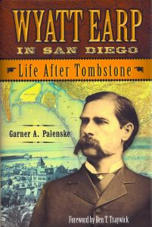 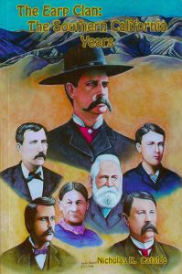

**Wyatt Earp In San Diego The Earps in S. California**  
 *By* *Garner Palenske By Nicholas Cataldo*

Hearing your many requests, this year we are presenting TWO incredible authors whose dedicated research has uncovered even more of the real true life story of Wyatt Earp and his family.

Author, lecturer and historian **Garner Palenske** spent 8 years chronicling the Earp's years in San Diego, where Wyatt bought property, established gambling houses, owned racehorses and became one of the main power brokers in the tightly controlled local gambling syndicate. He concentrated on making money, both legally and illegally. Wyatt's walking a thin line with the law in San Diego is a fascinating, rough and tumble story that is often filled with controversy.

**Nicholas Cataldo** is a past President of the San Bernardino Historical Society, a renowned educator, Columnist, and Earp Historian focusing on Southern California. Wyatt and his family came west by wagon in 1864. For the next 65 years, he would be in and out of California, finding it a safe haven, before, during and after his turbulent Tombstone days. Wyatt drove freight wagons, refereed boxing matches, ran card games, and mined for gold and oil. In later years, Wyatt became good friends with cowboy movie stars William S. Hart and Tom Mix who were both pallbearers at Wyatt's funeral here in Los Angeles. There are many wonderful stories to be told about Wyatt and his family in Southern California.

Hear these two insightful authors for one night only, in the magnificent living room of Bill Hart's 10,000 square foot Mansion, high atop the hill in Hart Park. There is nothing like the experience of hearing true stories about a real west icon while sitting among the western paintings and collections of William S. Hart, the granddaddy of western movie heroes and real life friend of Wyatt Earp.